EASTER TALK: DAILY RESURRECTION
What an honor to be speaking to you tonight. My thanks to Third Church of Christ, Scientist, New York City for their invitation; and thanks to all of you for tuning in.

In his book about Mary Baker Eddy, the Discoverer of Christian Science, titled, Rolling Away the Stone, its author Stephen Gottschalk, explains, “This (book) cuts through and rolls away a number of barriers beyond the one to which (the book’s) title alludes. It takes seriously the theological production of an individual outside the well-groomed tradition of professional Protestant theologizing, …, and a woman at that.”

This 19th century theologian from New England, Mary Baker Eddy, provided for the world, Biblical insight and an ascending pathway spirit-ward, an uplifted view which enables us to restore, reclaim or resurrect, daily, our spiritual natures. Her inspired writing lifts us across the chasm of materialism up to the divine truth of existence, described in Genesis, as God’s image and likeness. Referring to the resurrection, the Founder of the Christian Science Church wrote in her primary work, Science and Health with Key to the Scriptures,

(READ FROM THE BOOK)

“Through all the disciples experienced, they became more spiritual and understood better what the Master had taught. His resurrection was also their resurrection. It helped them to raise themselves and others from spiritual dullness and blind belief in God into the perception of infinite possibilities. They needed this quickening, for soon their dear Master would rise again in the spiritual realm of reality, and ascend far above their apprehension. As the reward for his faithfulness, he would disappear to material sense in that change which has since been called the ascension.”
(SH. 34:18) Further on she wrote: (CONTINUE READING from THE BOOK)

“By striving to follow and obey the teachings of Jesus, we will experience our own resurrection”. RESURRECTION, is defined in Science and Health as “Spiritualization of thought; a new and higher idea of immortality, or spiritual existence; material belief yielding to spiritual understanding” (SH 593)
Let’s explore the thought that Jesus’ resurrection is also our resurrection—our daily resurrection.

The last 100 pages of THIS BOOK, (HOLD IT UP IN VIEW OF CAMERA) contains over 70 verified healings, or an uplifted and resurrected life.

Let me share excerpts from just a few:
(KEEP READING from THE BOOK IN VIEW OF CAMERA)
“Nine years ago my only child was hovering between life and death. Some of the best physicians in Boston had pronounced his case incurable, saying that if he lived he would always be an invalid and a cripple. One of the diseases was gastric catarrh. He was allowed to eat but very few things, and even after taking every precaution, he suffered to the extent that he would lie in spasms for half a day. He also had rickets; physicians saying that there was not a natural bone in his body.
It was while he was in what seemed to be his greatest agony, and when I was in the darkest despair, that I first heard of Christian Science. ... I was willing to try anything to save my child, and the following Friday evening I attended my first meeting, which was in The Mother Church of Christ, Scientist, (In Boston). ... I realized from the testimonies given that Christian Science was the religion for which I had been searching for years. The next day I went to find a practitioner, (LOOK UP TO THE CAMERA AND SAY, now, a Christian Science practitioner is an individual in the healing ministry of Christian Science) ... On my way home I thought of some of the testimonies which I had heard the night before, — of people being healed by simply reading Science and Health. ...
I read it silently and audibly, day and night, in my home, and although I could not seem to understand it, yet the healing commenced to take place at once. The little mouth which had been twisted by spasms grew natural and the child was soon able to be up, playing and romping about the house as any child should...
... I was healed of all my complaints whilst seeking the truth for my child, ... All of this is, however, nothing to compare with the spiritual uplifting which I have received, and I have everything to be thankful for. — M. T. W., Los Angeles, Cal. (SH 612)
From Toledo, Ohio, EJR writes: I had long been a member of a Bible class in an orthodox Sabbath school, but I never felt satisfied with that which was taught; there was something lacking, I did not understand then what it was. I purchased a copy of Science and Health and began to study it. I wish I could

express in words what that book brought me. It illumined the Bible with a glorious light and I began to understand some of the Master's sayings, and tried to apply them.
I had had a longing to live a better Christian life for many years, and often wondered why I failed so utterly to understand the Bible. Now I knew; it was lack of spiritual apprehension.
I did not know at first that people were healed of disease and sin by simply reading Science and Health, but found after a while that such was the case. At that time I had many physical troubles,

and one after another of these ills,
simply disappeared and I found that I had no disease, — I was perfectly free. The spiritual uplifting was glorious,..(SH 643)

And one more, a Mrs. MM from Chicago, who wrote: Christian Science has not only helped me mentally, morally, and physically, but the greatest blessing of all is the spiritual uplifting which enabled me to know that God is both able and willing to care for His children, if we are but willing to do our part and bear the cross which, though it seems heavy at times, always brings a sure reward. …

The Bible is a new book to me. I now see what Jesus meant when he said, “Come unto me, all ye that labor and are heavy laden, and I will give you rest.” (SH 698)

A point of explanation here. When people testify that they have been healed by simply reading “the book” we do not want to give the impression that the words healed them. Reading the Christian Science textbook, studying the Bible, reading articles in the Christian
Science periodicals are all very inspiring
and lay the groundwork for shifting thought from a material view of life to an inspired, spiritual view. However, the letter is not a substitute for the Spirit.

The letter, while critically important, is only the human auxiliary that serves to align our thinking with the spiritual, which allows us to receive the revelation of Christ. Once your true natures are revealed then healing can take place. It is a spiritual uplifting or resurrection of thought. The ideas in Science and Health open the necessary avenues to understand better our spiritual nature. …and this is the theme of this talk today.

So, what was this “spiritual uplifting” or daily resurrection, that these three and the other 70 experienced, as well as millions over the next 150 years?
I’ll share two examples in nature to help us understand:

One year, while my wife and I were on our way to Vermont from New York. We passed through the Northwest corner of Massachusetts, and stopped in West Adams at The Massachusetts Museum of Contemporary Art (known as Mass MoCA). As I pulled into the parking lot, I saw six live trees inverted and suspended upside down from a truss made up of a metal armature, stainless steel planters, and telephone poles.

SLIDE 1
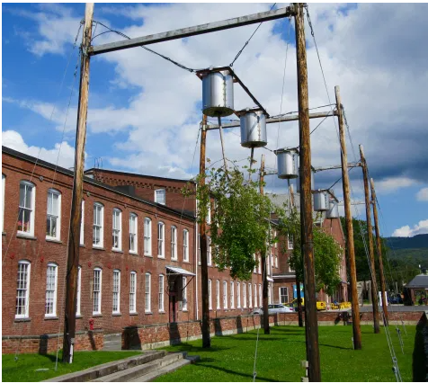
“Look at those upside down trees!, I said to my wife”. The trees turned out to be a (1999) work of art by Natalie Jeremijenko called Tree Logic. …the art of the piece is not found in its condition at any single point, but in the change of the trees gradually over time.

Trees grows away from the earth and towards the sun. When inverted, the six trees in this experiment still grow away from the earth and towards the sun, bending up, including the trunk!
SLIDE 2
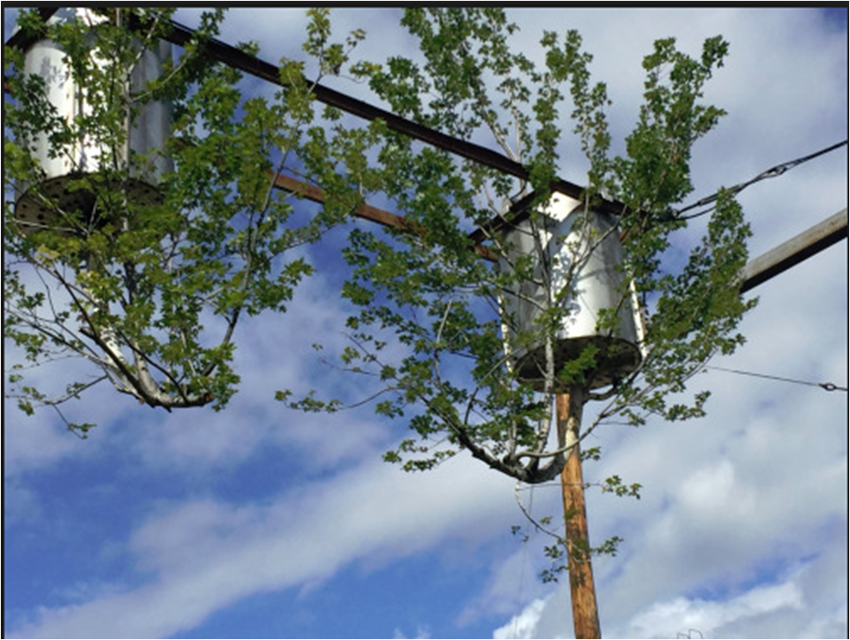
— so the natural predisposition of trees might well produce the most unnatural shapes over time, raising questions about what the nature of “natural” is.”

A second example of natural ascendancies occurred years ago during a severe ten-year drought in California’s Mojave desert. There was concern that the seeds of the annual desert blooms had died. (They generally do after about 7 years.) However, the following year there was rain, and lots of it, flooding the desert floor. Sure enough, the following spring the blooms returned.
SLIDE 3
In the Bible we read about the “scent of water”. Reading from Job 14: “For there is hope of a tree, if it be cut down, that it will sprout again, and that the tender branch thereof will not cease. Though the root thereof wax old in the earth, and the stock thereof die in the ground; Yet through the scent of water it will bud, and bring forth boughs like a plant.”(Job 14:7–9) Just as the dormant seeds were awakened by the scent of water, a flood of inspiration will awaken our dormant thought.

What do these two examples have in common: well, they both illustrate a natural uplifting toward their source of nourishment. They ascended naturally and involuntarily.
Mrs. Eddy writes, (Tab 1 in SH) “Spiritual development germinates not from seed sown in the soil of material hopes, but when these decay, Love propagates anew the higher joys of Spirit, which have no taint of earth.” (SH 66:11–14) “Mortals must gravitate Godward, their affections and aims grow spiritual,—...” (SH 265)

When the lives of the three testifiers were turned upside down or their spiritual inspiration lay dormant, they found a spiritual source and gravitated spirit-ward, thus countering the natural law of material gravitation. They bridged the gulf that exists between the human struggle and their divine natures. The Bible refers to “the horrible pit” or the “fiery furnace” but through prayer they were lifted out of their situations and buoyed up to health and vitality. Those testifiers along with millions of others touched by the risen Christ were released from the earth-weights of material gravitation holding them down and found the scent of water and the sunlight of Truth and began their ascending path of spiritual discovery and a life reclaimed and resurrected. In Mary Baker Eddy’s own recovery from a fall on the ice, from which the doctor’s indicated there was no hope of recovery, she was asked by a dear older lady, “How is it that you are restored to us? Has Christ come again on earth?” “Christ never left,” she replied; “Christ is Truth, and Truth is always here, — the impersonal Saviour.” “...I love the Easter service: it speaks to me of Life, and not of death. Let us do our work; then we shall have part in his resurrection. (Mis. 180)
SLIDE 4
I love the Easter service: it speaks to me of Life, and not of death. Let us do our work; then we shall have part in his resurrection. -MARY BAKER EDDY

When our lives are turned upside down our hungering for something better, higher, and yes, holier, increases. In her textbook Mrs. Eddy assures us the “The loss of earthly hopes and pleasures brightens the ascending path of many a heart.” (SH 265)
In an article that appeared in the June 1975 Christian Science Journal, titled Pathway of Ascension, the author, Naomi Price, writes: “The climax of Christ Jesus' mission on earth was reached when his consciousness was so uplifted with the understanding of spiritual reality that material sense could no longer tempt him. Luke’s Gospel, chapter 24, tells of the moment when he led his disciples “out as far as to Bethany, and he lifted up his hands, and blessed them. And it came to pass, while he blessed them, he was parted from them, and carried up into heaven.” (Luke 24: 50-51)
Put differently, escaping from, or growing out of, a material sense and rising to a spiritual sense of ourselves is daily resurrection.…
As we read in Paul’s letter to the Ephesians (4:22-24) (Tab 1 in the NRSV Bible) in the New Revised Standard Version of the Bible, “You were taught to put away your former way of life, your old self, corrupt and deluded by its lusts, and to be renewed in the spirit of your minds, and to clothe yourselves with the new self, created according to the likeness of God in true righteousness and holiness.” Put more concisely, Eddy advised us “to abide in our unselfed better self…(My. 6:6). To me that means get the material concept of self out of the way and let God take over.

Here is an example from my own experience: Some years back, we took a family vacation to Cabo San Lucas in Baja
California, Mexico. At the tip of Baja where the Pacific Ocean meets the Sea of Cortez, the waters can be very rough, to the point that swimming is now not permitted on the Pacific Ocean side.
SLIDE 5
However, from the Pacific side, where our hotel was located, there is a rocky ridge that people can climb over to get to the peaceful Sea of Cortez side. My grandson and I set out to do just that. He easily made it up over the rocks. However, weighing quite a bit more —and carrying shoes, towels, and swim gear—I was unable to do it. I have swam around the tip before in calmer conditions, but this time I decided to make a run for it around the rocks while the waves recessed—not the best idea. When the waves came in, and before I could make it around, they picked me up
and took me out to sea, I felt like I was inside a washing machine. Within a couple of seconds I was about 150 feet out into the deep. No sooner was I dragged out to sea than I was violently thrown back into the rocks. While making every effort to escape, I was swept out again. This went on several times until I was exhausted. I felt myself being pulled under and was fighting to get to the surface to get air. I kept fighting the waves, but to no avail; my strength was being exhausted, and I felt myself passing out. There appeared to be no way to escape.
It was then that my thought reached out to God. I remember what came to me: “Lead me to the rock that is higher than I” (that is from Ps. 61:2). I repeated this several times, and while at first it was a demand, it finally became a declaration of fact. The thought came to me to go to the ocean floor and crawl further out to sea, instead of trying to stay on the surface of the water and swim toward shore. How could doing the opposite of what would be the normal inclination, help me? Yet I was obedient to this inspired thought. With what little strength and breath I had left, and grabbing the sand, I crawled 15 or 20 feet further out. Then I passed out. The next thing I knew, I was on the beach on the Sea of Cortez side. Evidently, when I crawled further out, the waves shot me back in at a different trajectory to the other side of the rocky ridge. When I regained consciousness, two very kind locals were helping me, along with my grandson. I was in pretty bad shape and they in their own way were nursing me, cleaning me up, and staying with me until I could gain a sense of control again. My grandson and I repeated lines from familiar hymns, and he supported me until I was able to get up. We caught the next water taxi and together we then walked back to the hotel.
Shortly after this event, I recalled what a Christian Science friend once told me. He
said, “If you want the spiritual solution to a problem, simply reverse the material claim. As an example, if the thought comes to you, ‘I am going to die,’ reverse the words in the sentence and declare, ‘I am coming to Life!’ During that experience in the ocean, I came to Life—to the recognition of my spiritual reflection of God, who is all Life. By doing the opposite of what human reasoning was telling me, I listened to, and followed, the inspiration that became answered prayer…resurrection in daily life.
Later on, I found the following statement
in Science and Health, which resonated with me: (Tab 2 in SH) “Waking to Christ’s demand, mortals experience suffering. This causes them, even as drowning men, to make vigorous efforts to save themselves; and through Christ’s precious love these efforts are crowned with success.” (SH22:6)
That experience was re-lived for me in Andrea Day’s song Rise Up:
You’re broken down and tired
…I’ll rise like the day -I’ll rise up
I’ll rise unafraid- I’ll rise up
And I’ll do it a thousand times again
And I’ll rise up- High like the waves
I’ll rise up- In spite of the ache
I’ll rise up -And I’ll do it a thousands times again When the silence isn’t quiet
And it feels like it’s getting hard to breathe
And …you feel like dying… I’ll rise up I’ll rise like the day I’ll rise up
I’ll rise unafraid -I’ll rise up
And I’ll do it a thousand times again

What is the secret of rising up?: Well, let’s shift the subject then to humility, the key ingredient to taking part in our daily resurrection. In Luke 14, Jesus Teaches us about humility. Starting at verse 7,

(READ from Tab 2 in THE BIBLE)

When Jesus noticed that all who had come to a dinner party were trying to sit in the seats of honor near the head of the table, he gave them this advice: “When you are invited to a wedding feast, don’t sit in the seat of honor. What if someone who is more distinguished than you has also been invited? The host will come and say, ‘Give this person your seat.’ Then you will be embarrassed, and you will have to take whatever seat is left at the foot of the table! “Instead, take the lowest place at the foot of the table. Then when your host sees you, he will come and say, ‘Friend, we have a better place for you!’ Then you will be honored in front of all the other guests. For those who exalt themselves will be humbled, and those who humble themselves will be exalted.” So unselfing our better self, starts with humility…
In the 4 versions of the Gospel there are 28 illustrations of healings by Jesus. In many of them humility is one of the key characteristics displayed by those healed. It takes humility to realize you need help and be willing to reach out for it. Recall the woman with issue of blood “unclean”, who, on her knees reached for the Master’s robe; or Mary Magdalene pouring oil on his feet and washing his feet with her tears; the Nobleman’s dying son and Jairus’s daughter, both raised from the dead; the palsied man lowered down through the tiling’s, or the Canaanite woman whose son was “grievously vexed” and begged simply for the crumbs that fell from the Master’s table. All of them displaying, with humility, a hungering for something better, holier, higher than their present circumstance.
That is what his resurrection means to me, that anything can be new again. Every day is new.

The resurrection means that there is nothing so final that it prevents us from starting over. It’s never too late to begin anew. No failure is final. No offense is unforgivable. There isn’t any loss that can’t be recovered. Eddy writes “that we can be brought into no condition where divine Love as not gone before us and its tender lessons are not awaiting us”. In the resurrection there are no doors that are forever closed. When one door is closed God opens another. The resurrection assures us that God never gives up on us, even if we give up on ourselves. As Ps 96 states: “Sing unto the lord a new song…tell of His salvation from day to day.”
SLIDE 6
The resurrection means that there is nothing so final that it prevents us from starting over. It’s never too late to begin anew. No failure is final.

One Christian minister wrote that “…believing that Jesus rose physically from the grave, but also, and perhaps even more importantly, to believe that – no matter our age, mistakes, betrayals, wounds, and deaths – we can begin each day afresh, innocent again, a child, .., an infant stunned at the newness of it all. Resurrection is not just a question of one day, after death, rising from the dead, but it is also about daily rising from the mini-graves within which we so often find ourselves.”
How does belief in the resurrection help us rise from these “mini-graves”? By keeping us open to surprise, awe, newness, and freshness in our lives.

Not always an easy thing to do. Sometimes we seem to fall – into depression, bitterness, sin, betrayal, cynicism, and the tiredness that comes with age. Like Jesus, we too will have our crucifixions. More than one challenge awaits us. Yet our faith in the resurrection invites us to live beyond these. Aptly put: What the resurrection teaches us is not how to live – but how to live again, and again, and again!”—Just as Andrea Day’s song, RISE UP declares.

Psalms 40 (Tab 3 in the Bible) provides 6 useful and prayerful steps in daily resurrection. It reads

“1 I waited patiently for the Lord; and he inclined unto me, and heard my cry.
2 He brought me up also out of an horrible pit, out of the miry clay, and set my feet upon a rock, and established my goings.
3 And he hath put a new song in my mouth, even praise unto our God:

The Lord (1) inclines unto us, (2)hears our cry, (3) lifts us up, (4) sets our feet upon a rock, (5) establishes our goings and (6) puts a new song in our mouth.

Quoting that same 1974 Naomi Price Journal article, “As we gravitate Spirit-ward, the supposed law of material gravitation is neutralized.” We are lifted out of situations that the Bible metaphorically refers to as a horrible pit, a fiery furnace, a lions’ den. …. We are relieved of earth-weights…”(Naomi Price, Pathway of Ascension June 1975 Journal)
SLIDE 7
“As we gravitate Spirit-ward, the supposed law of material gravitation is neutralized.”– Naomi Price

I mentioned examples of people, who in their humility, were raised from their “mini-graves”. We need not look any further than Jesus’ parable which defines humility…that of the Prodigal son who spent all his inheritance on “riotous living” and finally turned from feeding swine, to return to his Father, and was then resurrected to his rightful status of sonship. It is interesting to note that when the son was a great way off, the Father saw him and ran to him. Three historical Bible characters, (two of which God selected and resurrected from their lowest points), stand out to me. I refer to Jacob, Moses and Mary Magdalene.

Jacob was hiding from his twin brother Esau, from whom he stole for his father’s blessing. Known as the “trickster”, illustrated by his outwitting his Uncle Laban to marry both of Laban’s daughters. Then, Jacob moved on. As he approached his home territory, he knew there would be a confrontation with Esau, his wronged brother. He heard that Esau had set out looking for him with 400 men, and he was afraid…

That night, standing alone by the River Jabbok, a solitary man approached Jacob and began to wrestle with him. They wrestled and fought all night, but neither could get the upper hand.
Then the stranger struck Jacob in the hollow of his thigh, and Jacob’s hip was dislocated. But Jacob held on. The stranger told him to let go, but Jacob demanded a blessing before he would do so. ‘What is your name?’ asked the stranger. ‘Jacob’. ‘Now it is no longer Jacob, but Israel’, said the stranger, confirming his resurrection day, since Jacob knew that he had seen God face to face – and lived.

Then we come to Moses, a fugitive, wanted for murder of an Egyptian, hiding out as a shepherd at his Father-in-law, Jethro’s place in the mountain of Horeb. It was at that mountain where Moses sees the burning bush and God tells him, “the place whereon thou stands is holy ground. He was elevated to be the great leader who led the Children of Israel out of slavery across the Red Sea and gave us the Ten Commandments. Quite a rise for both of these men, one from his humble status as a sheepherder and the other from being a thief and con man.

However, it is Mary Magdalene, to me, who represents the highest example of humility. Seen at the Master’s feet when she interrupted Simon the Pharisee’s feast honoring Jesus, washing his feet with tears and sacrificing costly oil to show her contrition. Later, we again find her at the Master’s feet, listening to him preach, where she lived with her sister Martha, “choosing the better part” as Jesus put it, when Martha asked him to tell Mary to get up and help her. This 13th disciple, as some have called her, was present during the crucifixion, first to seek the Christ at the sepulcher three days later, and first to share the news of the risen Christ with the other disciples.

In all three cases, God inclined to them, heard their cry lifted them up, set their feet upon a rock, established their purpose and gave them each a new song. As is with so many other Biblical examples, thought was lifted from a limited human concept of themselves to a spiritual revelation of a “better self”, the self referred to in Hymn 20 of our hymnal, which reads:
Be true and list the voice within,
Be true unto thy high ideal,
Thy perfect self, that knows no sin,
That self that is the only real.
And again in Hymn 66,
That higher selfhood which
we all must prove,

The question becomes, How? How do we rise up. How do to turn from a limited sense of self to access unlimited spiritual power? The answer is in reflection as opposed to reaction. Reaction is caused by an outside event of influence controlling our thinking to create, fear, anger, pain or pleasure. Reflection, on the other hand, is the thoughtful expression of God-given spiritual qualities of peace, love, kindness, patience and compassion. Before allowing ourselves to unconsciously react to a word, event, advertising or news reports, we should stop, listen for how we can express our better self and in silent prayer humbly seek divine inspiration. It requires developing the habit of asking, “Father, what would Thou have me to do?” How can I respond with Love? How can I see my fellow man better? How can I replace my dystopian view of the world and see myself and everyone else as “fellow-saints of a holy household”? It really boils down to a daily, even hourly way of thinking. I decided one time to count the number of times the word “daily” appeared in the writing of Mrs. Eddy. I was looking for things I should be doing each day to be a better Christian Scientist, and for that matter a better Christian. I found 23 of them. Examples include: letting the reign of Truth, Life and Love be established in me; not letting animosity or mere personal attachment impel my actions, having gratitude and love in my heart every day, examining my thought to see if there is a deterrent to Truth, to love my neighbor as myself, to do some good deed every day, to bless our enemies, to pray for peace, in other words, to follow Christ in our daily life. (Email me at mmooslin@gmail.com if you would like a complete list of the 23 dailies.)
It requires a conscious daily effort to shift thought in order to free ourselves from the concept of a mortal, separated from God, and reveal the spiritual image and likeness we read about in Genesis, thus being at one with God, never separated. Every discord, every illness, evey complaint have one thing in common. They all come from a concept of ourselves as a mortal with physical limits, separated from Love as opposed to our higher selfhood as the spiritual embodiment of Love, itself. Remove the limited sense of self and those discords have nothing to attach themselves to in our thought.

I’ll share a somewhat simple and less dramatic example of how this works. It requires inspiration vs. human will. Early in our marriage and with a new baby girl, we felt it was time to buy our first house. At the time monthly mortgage payments could not exceed 25% of one’s monthly salary. The only houses we could qualify for were rather modest tract homes and with interest rates at the time our payments were still going to be a reach. We were letting external financial limits dictate our situation and defining where we would live. I called a Christian Science practitioner and she immediately reminded me of a sentence in the textbook, “Divine Science, rising above physical theories, excludes matter, resolves things into thoughts, and replaces the objects of material sense with spiritual ideas. (SH 123:12). Not grasping the full meaning of what she was saying, she made it more practical. “You do not need to search for a house”, she explained. Instead you need to express gratitude for the home you already have, which includes safety, family, peace, love and harmony. Embracing and cherishing those God-provided qualities will manifest itself with everything you need. This is consistent with Mrs. Eddy’s statement, “Pilgrim on earth, thy home is heaven; stranger, thou art the guest of God.”
(SH 254:31) My wife and I immediately got to work, claiming our home. We saw that already dwelt in the kingdom of heaven. Early the next Saturday morning I received a call from a stranger saying that he had a home he needed to sell and heard that we were looking for a place from a work associate. (He used the specific term “HOME”. That afternoon we went to see it. It was a beautiful neighborhood with a house far nicer than anything we looked at. Although we thought it was way out of reach given our budget, we nonetheless decided to go in. We felt a bit intimidated walking into this beautiful two-story home. I had to tell him that I didn’t think our income would qualify us to make the mortgage payments. He said not to worry. His was an assumable, low interest VA loan and told me the payments, which although lower than I expected, still exceeded the 25% requirement. We thanked him and told him we would get back to him. We also mentioned that we had to honor our apartment lease which was up five months later. He replied that was the exact time of his transfer and the home would not be available until then. The following week I received a raise at work and my new income exactly, to the dollar, met the mortgage payment requirement. We told him we would go forward. Several weeks later he called me again, this time with bad news. He said that while we qualified for the mortgage payment test our overall financial condition required we fund an impound account to cover property taxes and homeowner’s insurance a year in advance. We started saving and knowing God had provided this opportunity and that our home was already established, we saved the amount needed by the required deadline, again to the exact dollar. Rather than being influenced by external events, over which we seemingly had no control, through shifting our thought to a home as an idea of Soul, we were able to actually see a God-directed outcome. It was a humbling experience, one in which we had to let go of all human will and instead humbly bowing before Him, seeking only to reflect His glory. This exchange of material limitations for unlimited spiritual provisions occurs through selfless, consecrated prayer. It results in inspiration. But, how do we know a thought is actually from God as opposed to just human thinking. There is a test that I have found effective in knowing the difference. An inspired thought has five characteristics:
- The new thought is free of self. (self will, self pity or self consciousness. “I” is not part of the new thought. (Home was a spiritual concept and already present.)
- It is free of lack. (Every financial condition was met without forcing it happen.)
- It is free of fear. (There was no threat of loss at any point)
- The new idea blesses all. The benefit does not mean a loss to anyone else. (Both the buyer’s and seller’s needs were met without any manipulation.)
- Unexpected good. Something you could not have planned. (Such was the Saturday morning phone call and the unexpected raise at work.)
SLIDE 8
In the case of finding our home, those five conditions were met and we could go forward with confidence.
When Jesus said, “I and my Father are one”, we could just as correctly say, “The sun and the sunray are one”. Now imagine that sunray believing he was separated from the sun with his own independent light and heat. Running low on energy he would turn to the sun and ask for more light and heat. The sun might rightly reply, “what are you talking about”? You are the very activity of light and heat. You are not a separate ray. (In our case we were asking God for a house and tried to make it happen anyway we could. However, we were already in possession of the idea, “home”, and only had to step aside and let it manifest itself. In like manner we should not be praying for more Spirit, more Love or more intelligence. Instead we need to understand that we are the very activity of Love Truth and Mind itself. These are not external influences but internal qualities that we express, and from which we could never be separated.
We as Christian Scientists understand such prayer to mean listening for the angels to speak to us as they did to Moses and Jacob and Mary, as well as to Gideon, and Saul, to David and countless others, including me on the ocean floor or in my search for our home. After all, the Bible tells us that “God knows what we have need of, even before we ask.” All resurrection in our lives is, in fact, revelation to thought which comes to us as inspiration, lifting us to see our spiritual, “unselfed, better self.” It’s the revelation of the Christ to an enlightened human consciousness. And, it requires humility to experience a shift in thought (be lifted up) and receive it. Our textbook teaches that, “It is the living Christ, the practical Truth, which makes Jesus “the resurrection and the life” to all who follow him in deed.” When we look to Jesus as our exemplar, we see this characteristic of humility from the very start, from his humble birth in the manger, his love for little children, his washing the disciple’s feet, all the way to his entry into Jerusalem on a lowly donkey for the start of the most important week in human history.
SLIDE 9
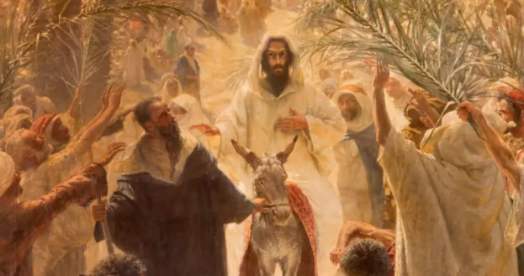
In John 3, speaking to Nicodemus about the need to be born again, Jesus said: “the Son of Man must be lifted up, so that everyone who believes in him will have eternal life.”-everyone? That must include you and me. As we hunger daily to have our part in the resurrection, like the Magdalene, we will find ourselves tending naturally to the infinite source of life. We are being drawn to the light of Christ, with an irresistible attraction. Like those tree branches, bending upward, we share in the resurrection. That is where healing takes place. However, that humble Nazarene’s popularity was a threat to Caesar as well as the control being exercised by the Pharisees and Sadducees of his time. The same threat was true of Herod at Jesus’ birth. Eddy writes:

(Tab 3 in SH READ FROM THE BOOK)

“Led on by the grossest element of mortal mind, Herod decreed the death of every male child in order that the man Jesus, the masculine representative of the spiritual idea, might never hold sway and deprive Herod of his crown”.(SH 565:9–13) They were all making a “grave mistake”. One might very well ask, Who or what are the Caesar's and Herod’s of our day, that are trying to kill the Christ. Do we not all have the duty to resist those material distractions, rise above them and find the risen Christ present in our lives?

Referring to Genesis i. 13. (And the evening and the morning were the third day.) The Discoverer of Christian Science and the Founder of our Church explains:

(Tab 4 in SH-READ FROM THE BOOK)

“The third stage in the order of Christian Science is an important one to the
human thought, letting in the light of spiritual understanding. This period
corresponds to the resurrection, when Spirit is discerned to be the Life of all,
and the deathless Life, or Mind, dependent upon no material organization. Our Master reappeared to his students, — to their apprehension he rose from the grave, — on the third day of his ascending thought, and so presented to them the certain sense of eternal Life.” (SH508:26–8) Who was the first to see the risen Christ that
resurrection morning? Of course, it was our humble heroine, the 13th disciple, Mary Magdalene.

SLIDE 10
‘Mary Magdalene Approaching the Tomb’, Gian Girolamo Savoldo, 1535-40

John 20 narrates for us: “Jesus, saith unto her, woman, why weepest thou?
She, supposing him to be the gardener, saith unto him, Sir, if you have borne him hence, tell me where you have laid him, and I will take him away.”

SLIDE 11

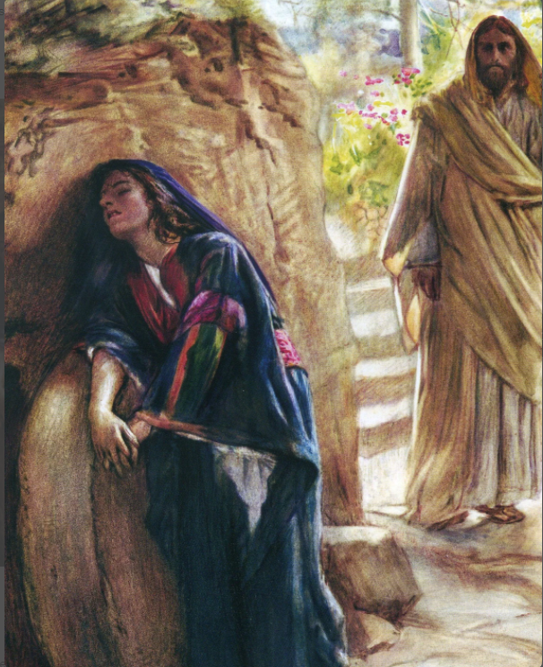

To me, then, what follows is the most tender and profound response. : “Jesus simply says to her, Mary. She turned herself, and saith unto him, Rabboni; which is to say, Master.

As Paul asks in 1 Thessalonians 2, “For what is our hope, or joy, our crown of rejoicing? Are not even ye in the presence of our Lord Jesus Christ at his coming?”

In a 1909 Christian Science Sentinel article, titled CROSS AND CROWN, Bert Miller writes, “When the command comes to us to take up the cross and follow Christ, Truth, the following leads in an entirely opposite direction from the one in which we have been going, and when we come to put our uplifted desires into actual practice it requires an effort much greater than we had anticipated, for we are now pulling against the current, battling with sense and self: but if we have sufficient faith in God, are depending on divine Love to sustain and aid us in the conflict, we are sure to win, and there is nothing to compare with such a victory.” He quotes Page 254, "If you launch your bark upon the ever-agitated but healthful waters of truth, you will encounter storms. … This is the cross. Take it up and bear it, for through it you win and wear the crown." That’s the end of the quote.

Let each of us have our part in the resurrection morning by turning our
cross-bearing experiences into our crown of rejoicing thereby rolling away the stone blocking our view of the Christ, so we too can turn and say, Rabboni, Master.

In closing I will read (Tab 1 in Prose Works) Mary Baker Eddy’s Easter Message, written in 1902:
Beloved Brethren: — May this glad Easter morn find the members of this dear church having a pure peace, a fresh joy, a clear vision of heaven here, — heaven within us, — and an awakened sense of the risen Christ. (MY 155:16–20)

Thank you everyone, and have a glorious Easter.

SLIDE LIST:
Slide 1
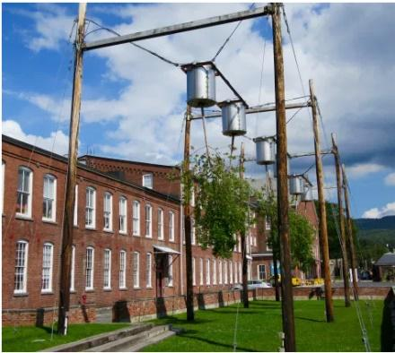

Slide 2
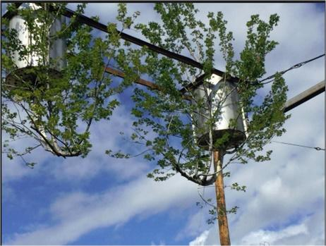
Slide 3
Slide 4
I love the Easter service: it speaks to me of Life, and not of death. Let us do our work; then we shall have part in his resurrection. -MARY BAKER EDDY

Slide 5
Slide 6
The resurrection means that there is nothing so final that it prevents us from starting over. It’s never too late to begin anew. No failure is final.

Slide 7
“As we gravitate Spirit-ward, the supposed law of material gravitation is neutralized.”– Naomi Price

Slide 8
Slide 9
Slide 10

Slide 11

